ActiveMQ Integration with Jboss 5.1

* This integration required for testing sample project in examples folder to work
* Copy the provided “activemq-ra-5.4.2.rar”(Misc) file in JBOSS_HOME/server/default/deploy
* Copy the provided “activemq-jms-ds.xml” (Misc) in JBOSS_HOME/server/default/deploy folder
* If you want to change the name of the queue then open “activemq-jms-ds.xml” in editor and change the existing queue or you can add new one.

**<mbean code="org.jboss.resource.deployment.AdminObject" name="activemq.queue:name=outboundQueue">**

**<attribute name="JNDIName">activemq/queue/outbound</attribute>**

**<depends optional-attribute-name="RARName">jboss.jca:service=RARDeployment,name='activemq-ra-5.4.2.rar'</depends>**

**<attribute name="Type">javax.jms.Queue</attribute>**

**<attribute name="Properties">PhysicalName=queue.outbound</attribute>**

**</mbean>**

* Start the server and you should see the following two queue being created. You might have diff name as per you activemq-jms-ds.xml file configuration

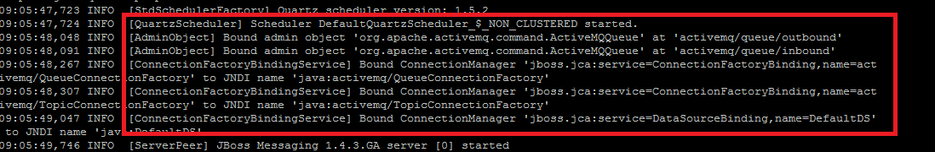

**Sample Communication Manager Project**

* Export the EAR file from examples folder to jboss
* Open a browser and go to <http://localhost:8080/CMTestWeb>
* Hit the button and you should see the message in JBoss console